Stop Mixing CDM, Ontology, and Knowledge Graphs



Thilo Hermann
Following
7 min read
·
Jul 2, 2026
518
13
2
Or: Why Your Data Architecture Feels More Complicated Than It Should
Press enter or click to view image in full size
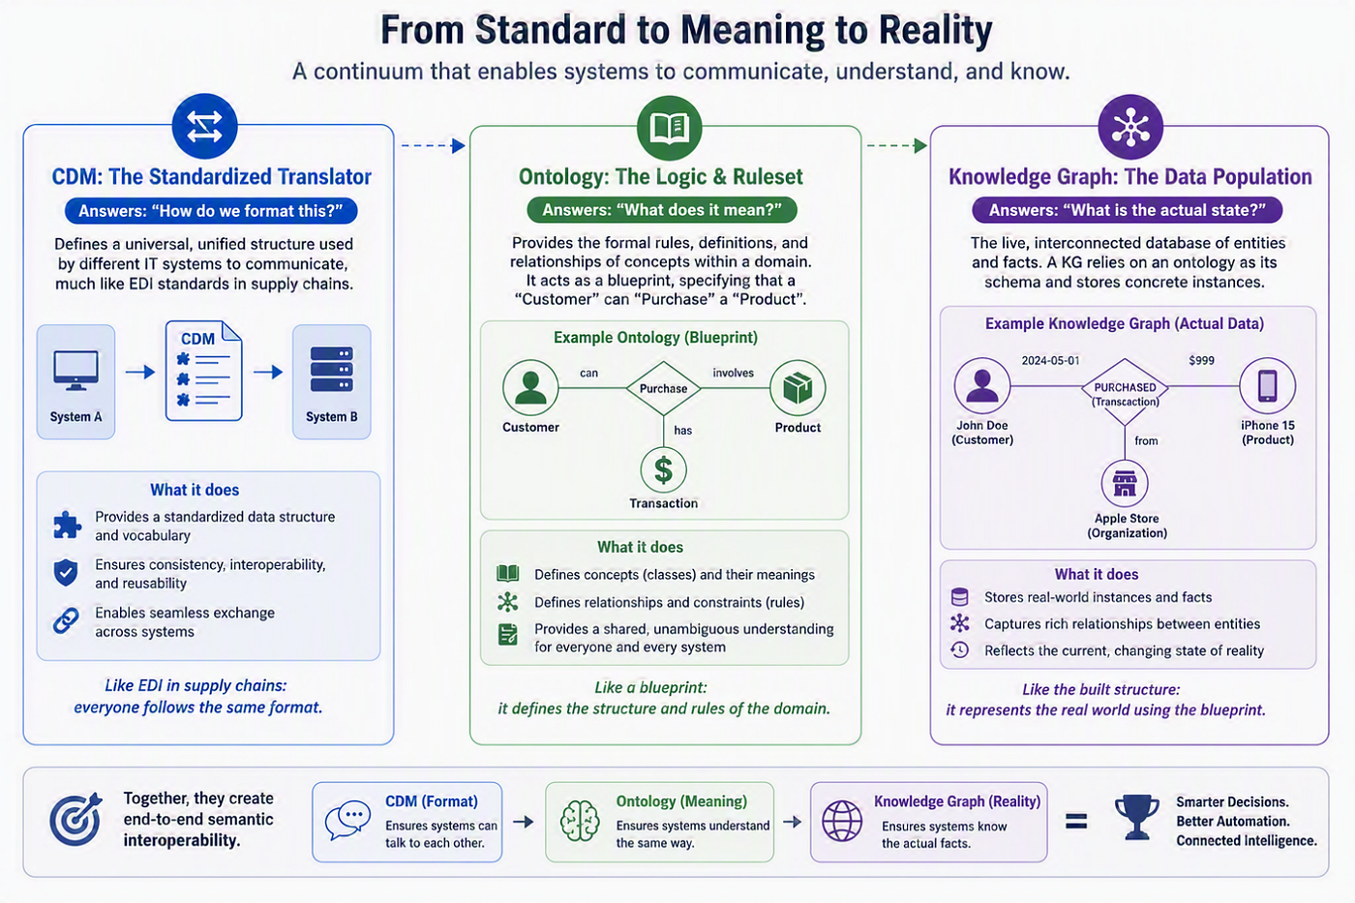
Generated by M365 CoPilot
Let me start with a question that has saved more than one architecture discussion from going off the rails: What problem are we actually trying to solve here?
You are not a medium member? This is the friend link to read the full blog …
Because if you’ve ever been in a workshop where someone casually throws around “Let’s build a knowledge graph,” you probably know the feeling. Heads nod. People get excited. Someone mentions AI. Someone else talks about APIs. And before long, three different concepts get mashed into one fuzzy idea.
Canonical Data Model. Ontology. Knowledge Graph. Same thing, right?
Not even close. And yet, they keep getting mixed up. Over and over again. In whiteboard sessions, in architecture decks, in vendor pitches. The result? Confusion, over-engineering, and systems that try to do everything at once — and end up doing none of it well.
So let’s slow this down and untangle the mess. Not academically. Not in theory. But in a way you can actually use the next time someone says, “Shouldn’t we just use a knowledge graph for that?”

The Temptation of the “One Model to Rule Them All”
There’s a pattern I’ve seen more times than I can count. A team starts with a simple integration problem. Systems don’t talk to each other. Data formats differ. APIs don’t line up. Pretty standard stuff.
Then someone suggests a Canonical Data Model. Good idea. Then someone else says, “While we’re at it, we should define the meaning of everything.” Also a good idea. And then — this is where things usually go sideways — someone jumps in with: “Let’s build a knowledge graph. That will solve it.”
At that moment, three layers collapse into one: structure, meaning, and data. And from there, complexity starts creeping in.
This is where a bit of architectural humility helps. As I’ve argued before in my post on the limits of silver bullets, there is no single solution that magically fixes everything. The same applies here: each layer solves a different problem, and treating them as one usually creates more work, not less.
So instead of chasing that illusion, let’s separate concerns.

The Canonical Data Model
Think of the Canonical Data Model, or CDM, as your translator. It doesn’t care about deep meaning. It doesn’t try to infer anything. It has one job: take different data formats and turn them into a standard structure. That’s it.
There’s also a practical reason this pattern matters. Without a canonical form, connecting N systems point-to-point means maintaining roughly N × (N-1) translations. Route everything through one shared format, and that collapses to N mappings. This is the classic integration argument formalized in Hohpe and Woolf’s Enterprise Integration Patterns (2003), which describes the “Canonical Data Model” as a named pattern.
Imagine you’ve got five systems:
- CRM
- Billing
- Logistics
- Mobile app.
- External partner API
Each has its own idea of what a “Customer” looks like. Different field names, different nesting, different formats. Probably different levels of quality, too.
The CDM steps in and says: “Here’s the format we all agree on. Map your data to this.”
In practice, a CDM is usually realized through schema and serialization standards — JSON Schema, XSD, Avro, or Protobuf — or a canonical message format. The exact choice depends on your context, but the goal stays the same: consistency of structure.
A useful mental image is a bilingual dictionary. It doesn’t explain the philosophy of a word. It doesn’t describe its evolution. It just helps you translate. And that’s powerful. Because without a shared format, nothing else works reliably — APIs break, pipelines fail, and data exchanges turn into brittle nightmares.
Still, let’s be honest: a CDM alone doesn’t tell you what anything actually means.

The Ontology
This is where things become more interesting — and also where confusion often starts. An ontology is not a data model in the usual sense. It doesn’t define payloads or API schemas. Instead, it defines concepts, relationships, and rules. For example:
- Concepts: Customer, Product, Order.
- Relationships: Customer purchases Product.
- Rules: A Customer can have multiple Orders; an Order must belong to one Customer.
In other words, it is a formal description of meaning. This aligns with the classic definition of an ontology as “a formal, explicit specification of a shared conceptualization” (Gruber, 1993). In practice, ontologies are often expressed using standards such as RDFS, OWL, or SKOS.
If the CDM is your dictionary, the ontology is your rulebook. Or, if you prefer something more visual, think of it as the blueprint behind the scenes. It answers questions like:
- What is a Customer in our business?
- How does a Product relate to an Order?
- What constraints apply?
And here’s the key point: the ontology primarily defines meaning and rules. Instance data is usually treated as a separate concern. In Description Logics, this is the distinction between the TBox (the schema and terminology) and the ABox (the actual assertions about individuals). Importantly, this separation is logical, not necessarily physical — both often live in the same graph store and are even queried through the same interface (for example, SPARQL). The point is that they play different roles, not that they must be stored apart.
That distinction matters. A lot.
Because when teams skip this layer, they often hardcode meaning into data formats or business logic. And that’s where inconsistency creeps in.
On the other hand, teams sometimes overcomplicate the ontology by trying to model every edge case imaginable. That’s when it’s worth asking a simple question: what would happen if we didn’t model this? Sometimes, nothing bad at all. And maybe that’s your signal to keep things simpler.

The Knowledge Graph
Now comes the part that usually gets all the attention. The knowledge graph. This is where real-world facts live. Not abstract definitions, not schemas, but actual statements about the world.
For example:
- Max Mustermann is a Customer.
- Max Mustermann purchased Product X.
- Product X belongs to Category Y.
So if the ontology defines what can exist, the knowledge graph represents what actually exists right now. It’s a network: nodes and edges. Entities and relationships. And yes, it often relies on an ontology or at least a shared schema to stay understandable and governable.
Without that underlying definition of meaning, a graph is just connected data. With it, you can start asking smarter questions, running inference, and connecting dots across domains.
That’s also why knowledge graphs are so attractive in AI discussions. They feel alive. They reflect reality. They support exploration, but they are not a replacement for everything else. They don’t automatically solve data exchange. They don’t replace APIs. They don’t magically clean your data. Remember: no silver bullet.

Where Things Go Wrong
Most of the problems I’ve seen around CDM, ontology, and knowledge graphs don’t come from the concepts themselves. They come from how we talk about them. Here are a few classics:
“Our knowledge graph is our data model.”
Not quite. A knowledge graph stores facts and relationships. A CDM defines structure for exchange. An ontology defines meaning. Blending them creates something that is hard to change and even harder to explain.
“Let’s define the ontology inside the CDM.”
Tempting, but risky. A CDM is about structure. An ontology is about semantics. Mixing them tightens coupling and limits flexibility.
“We don’t need an ontology, we’ll just use the graph.”
This is like building a city without zoning rules. You’ll get data in, but understanding it later becomes a guessing game.
“Let’s model everything upfront.”
This is where over-engineering sneaks in again. Investing heavily in complexity too early often solves problems that don’t exist yet — and creates new ones in the process.

How They Work Together
You can think of these three layers as a conceptual pipeline, even if real projects often evolve them in parallel. First, define meaning with the ontology. You start with the concepts that matter to your business: Customer, Product, Order. You define how they relate and what rules apply.
Next, capture reality in the knowledge graph. You populate those concepts with actual data: real customers, real transactions, real relationships. This becomes your live, interconnected view of the business.
Then, share and exchange through the CDM. You expose or exchange that data in a predictable format: APIs, data feeds, messaging systems. The CDM ensures that external systems can consume your data without guessing its structure.
Each layer has a clear purpose:
- Ontology → “What does it mean?”
- Knowledge Graph → “What is the actual state?”
- CDM → “How do we format this?”
And when each one sticks to its job, things become surprisingly manageable.

A Quick Reality Check
Do you always need all three? No.
Sometimes a CDM is enough. Sometimes you just need a well-structured database. Sometimes a lightweight ontology — or even just agreed definitions — does the job. What matters is that you don’t introduce complexity without a clear reason. Because every additional layer comes with a cost:
- More design effort.
- More alignment discussions.
- More governance.
And while good architecture thrives on clarity, it suffers from unnecessary weight.

Why It Matters Now
With GenAI, RAG, and agent-based systems entering the picture, these distinctions are no longer theoretical. They directly impact how well your data can be understood, how reliably systems can reason about it, and how easily you can connect different domains.
A knowledge graph without a clear ontology? Hard to trust.
An ontology without real data? Hard to use.
A CDM without shared meaning? Hard to interpret.
You don’t need perfection, but you do need clarity!

Closing Thought
The next time you’re in a discussion and someone says, “We should build a knowledge graph for this,” pause for a second.
Ask: Are we talking about structure? About meaning? Or about actual data?
Because chances are, you’re talking about three different things — and treating them as one. And maybe the most useful question you can ask is still the simplest:

